NLP Final Project

DATA 902 – Philip Bean

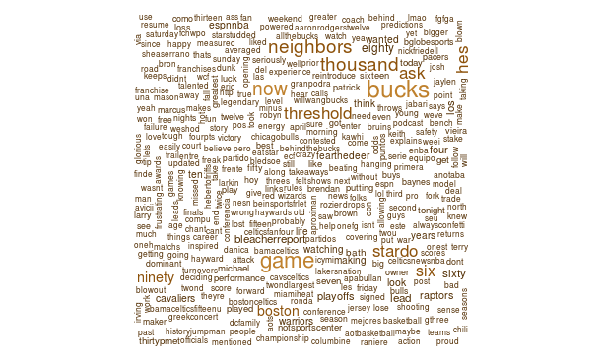

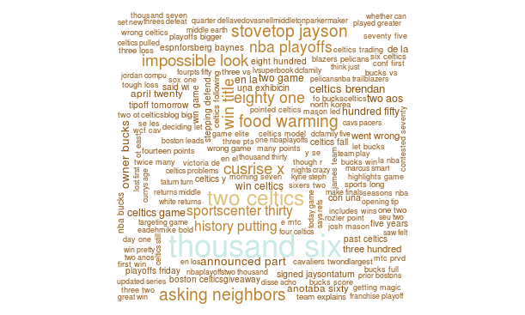

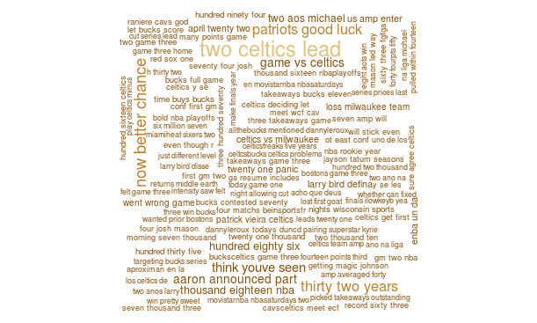

The wordclouds had varying levels of success. While creating wordclouds about the Celtics hashtag, I got all kinds of different varied information. However, the more popular terms seem to correlate with general buzzwords about the Celtics current playoff series.

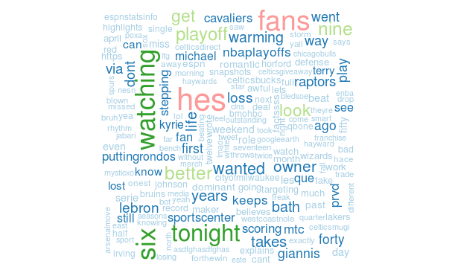

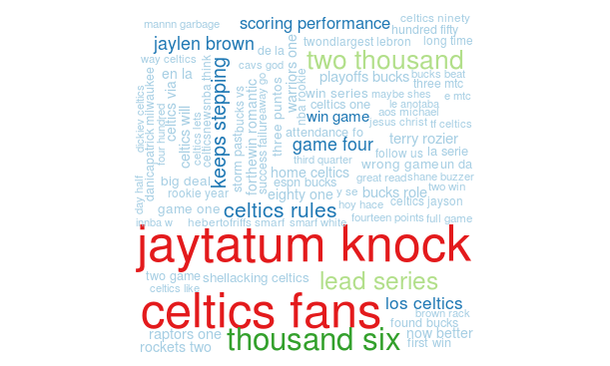

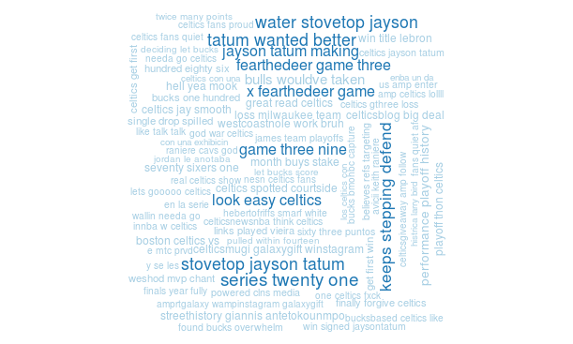

The wordclouds from the Inverse Document frequencies seem to have results more specific to the Boston Celtics themselves. The most frequent terms match the general buzz surrounding the team, but the more minor details seem to match better than the original wordclouds.

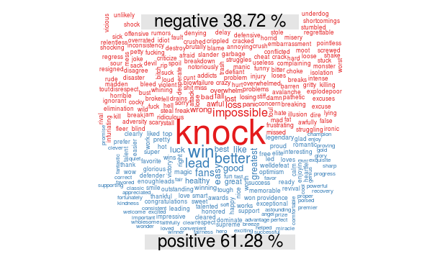

The comparison cloud produced especially noteworthy results. They support the positive sentiment that Celtics fans have despite an injury-plagued roster due to the relative ease of the Eastern Conference and the excellent coaching staff.

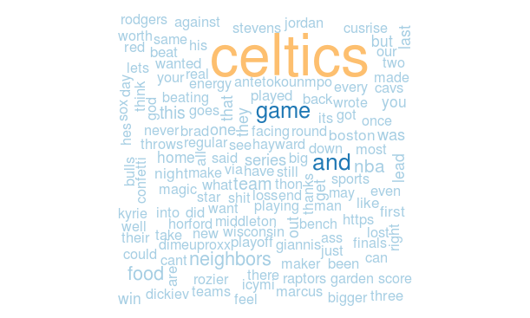

The commonality cloud predictably showed mostly generic information about the Celtics, the NBA, and their opponent, the Milwaukee Bucks. This is understandable because these more or less represent what people on Twitter were actually talking about and having positive/negative sentiments towards.

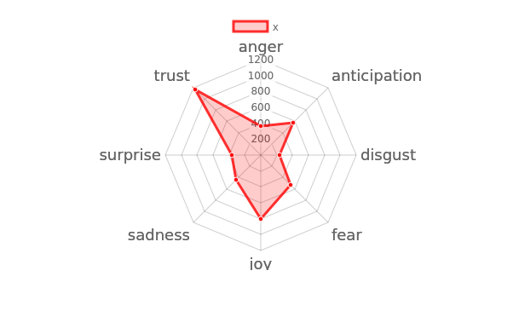

The radar chart was reflective of the previous generated charts. It shows that people believe in their team (with the high trust rating), are happy with their team (with the high joy rating), and they can’t wait for more (with the high anticipation rating).